JAYPEE INSTITUTE OF

INFORMATION TECHNOLOGY

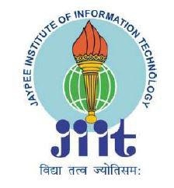

ALGORITHMS LAB

PROJECT

DELHI METRO DESKTOP APPLICATION

SUBMITTED BY:- SUBMITTED TO:-

Chitrank Mishra (17103103) Mrs. Ankita Wadhwa

Atharva Tripathi (17103127)

Ayush Saxena (17103108)

Trinendra Mehria (17103021)

DMRC

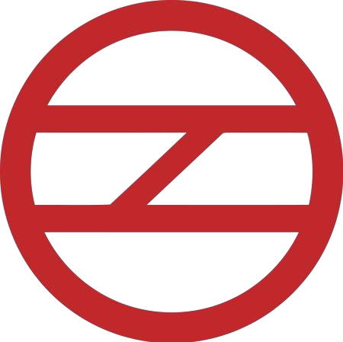

Data structures elements used in basic Algorithm :

1. Graphs: The shortest distance between two stations is calculated with the help of graphs.

Graph provides us nodes that can symbolize a single stations .Using graphs , the complexity can be reduced efficiently.

1. File handling :The map showing the stations all across the city can be entered and stored for further use using file handling.
2. Graphics\*: The application can be visually shown using the graphics . It gives the project a mature visual.
3. Vector: The entries can be stores in the vectors rather than using arrays as the size of the entry of the graph is big and unknown .

Overview :

We have covered the following grounds under this project :

Shortest route: Describing the route ,the passenger will take to reach the destination covering the shortest possible path. It is calculated using the djikstra() function.

Fare calculation :Depending upon the distance the he/she has travelled , the average fare will be charged according the rules laid down by DMRC and is calculated using the money() function.

Average time: The estimated time to reach the destination.

Stations in between : Stations which lie in between the path and train will stop there is shown using the path() function.

Average Distance : the expected average distance is calculated using the minDistance() function.

Change of lines: The user is also notified of the line he or she has to change and at which station to reach the destination.

Features Included :

It shows the

* Shortest Route between the stations
* Average fare
* Average time
* Average cost
* Average Distance
* No of Stations

Project Outcome :

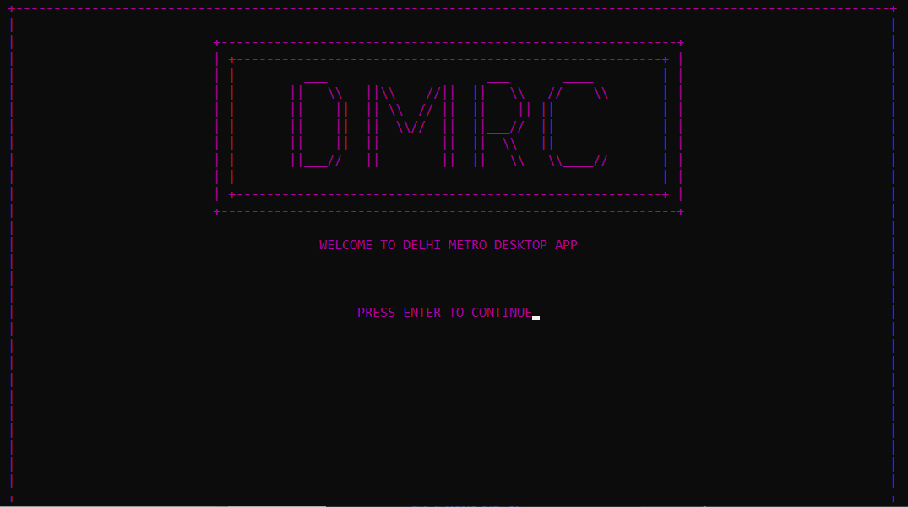

Introduction UI

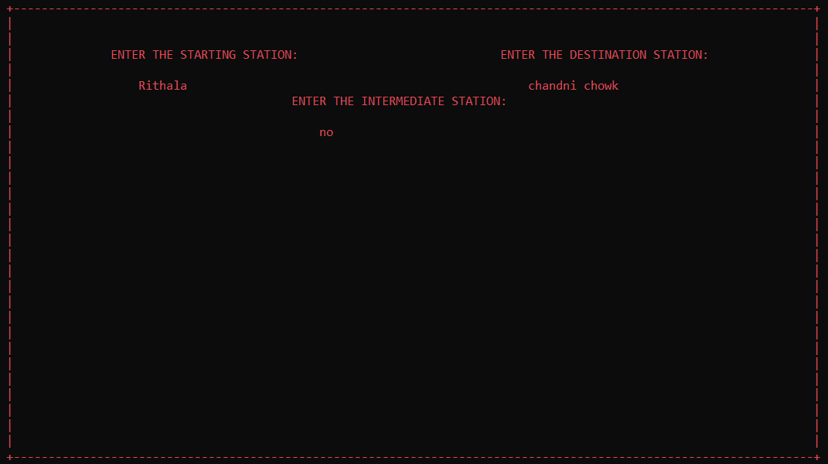

Enter station names dialog box

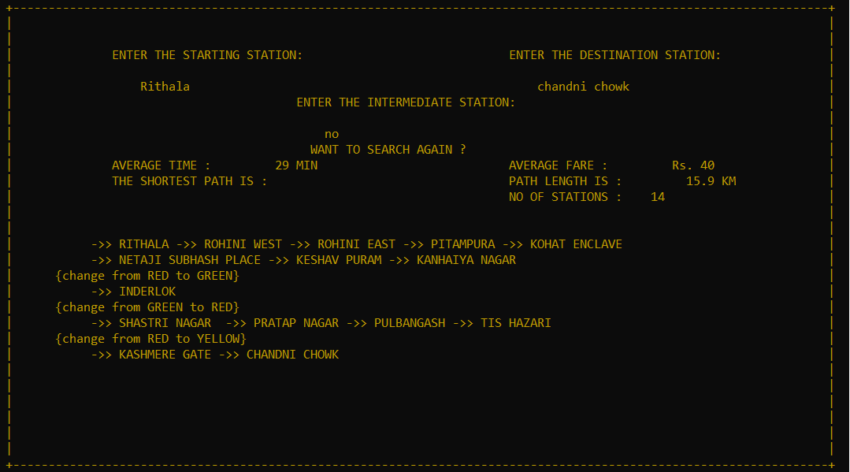

Route between two stations with no intermediate station provided

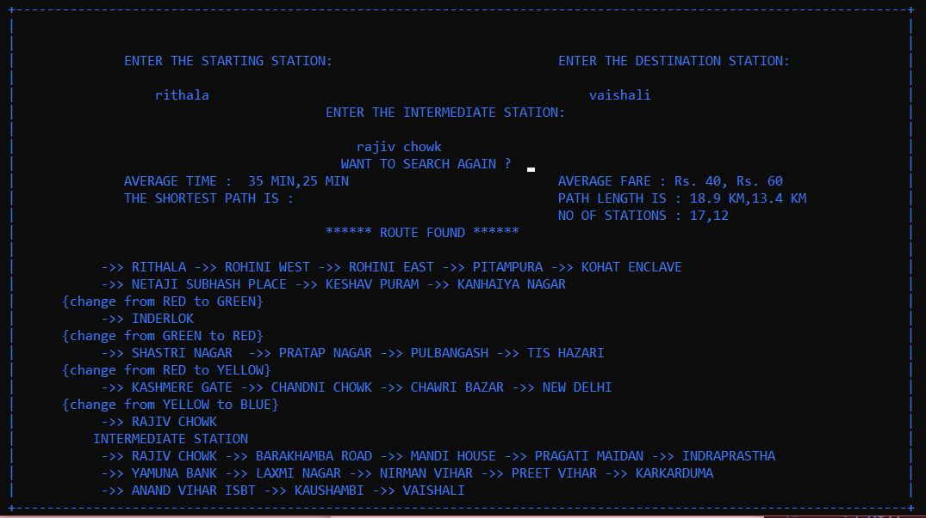

Route between two stations with an intermediate station

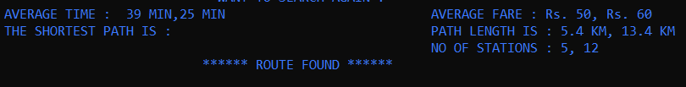

Features Included

Work Distribution :

Designing : Ayush and Trinendra

Algorithm implementation : Chitrank and Atharva

UI : Chitrank and Trinendra

Others: Ayush and Atharva

Expected Completion :

25th April 2019

Thank you for giving us this project.

It gave us an opportunity to learn a lot of new concepts.